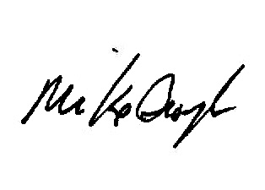

Lifeline Global Ministries®

CERTIFICATE OF COMPLETION

awarded to

*First Name Last Name*

for successfully meeting the requirements of

Malachi Dads: Heart of a Father - Part 1

at [Prison or Jail, City, State]  
***[Month date, year]***

________________________________________________________

Chief **[type Name here**)

________________________________________________________

**[type Name here)** Facilitator

________________________________________________________

**Mike Broyles** Director of Lifeline Global

And he will turn the hearts of the fathers to their children and the hearts of the children to their fathers…

**Malachi 4:6** (ESV)