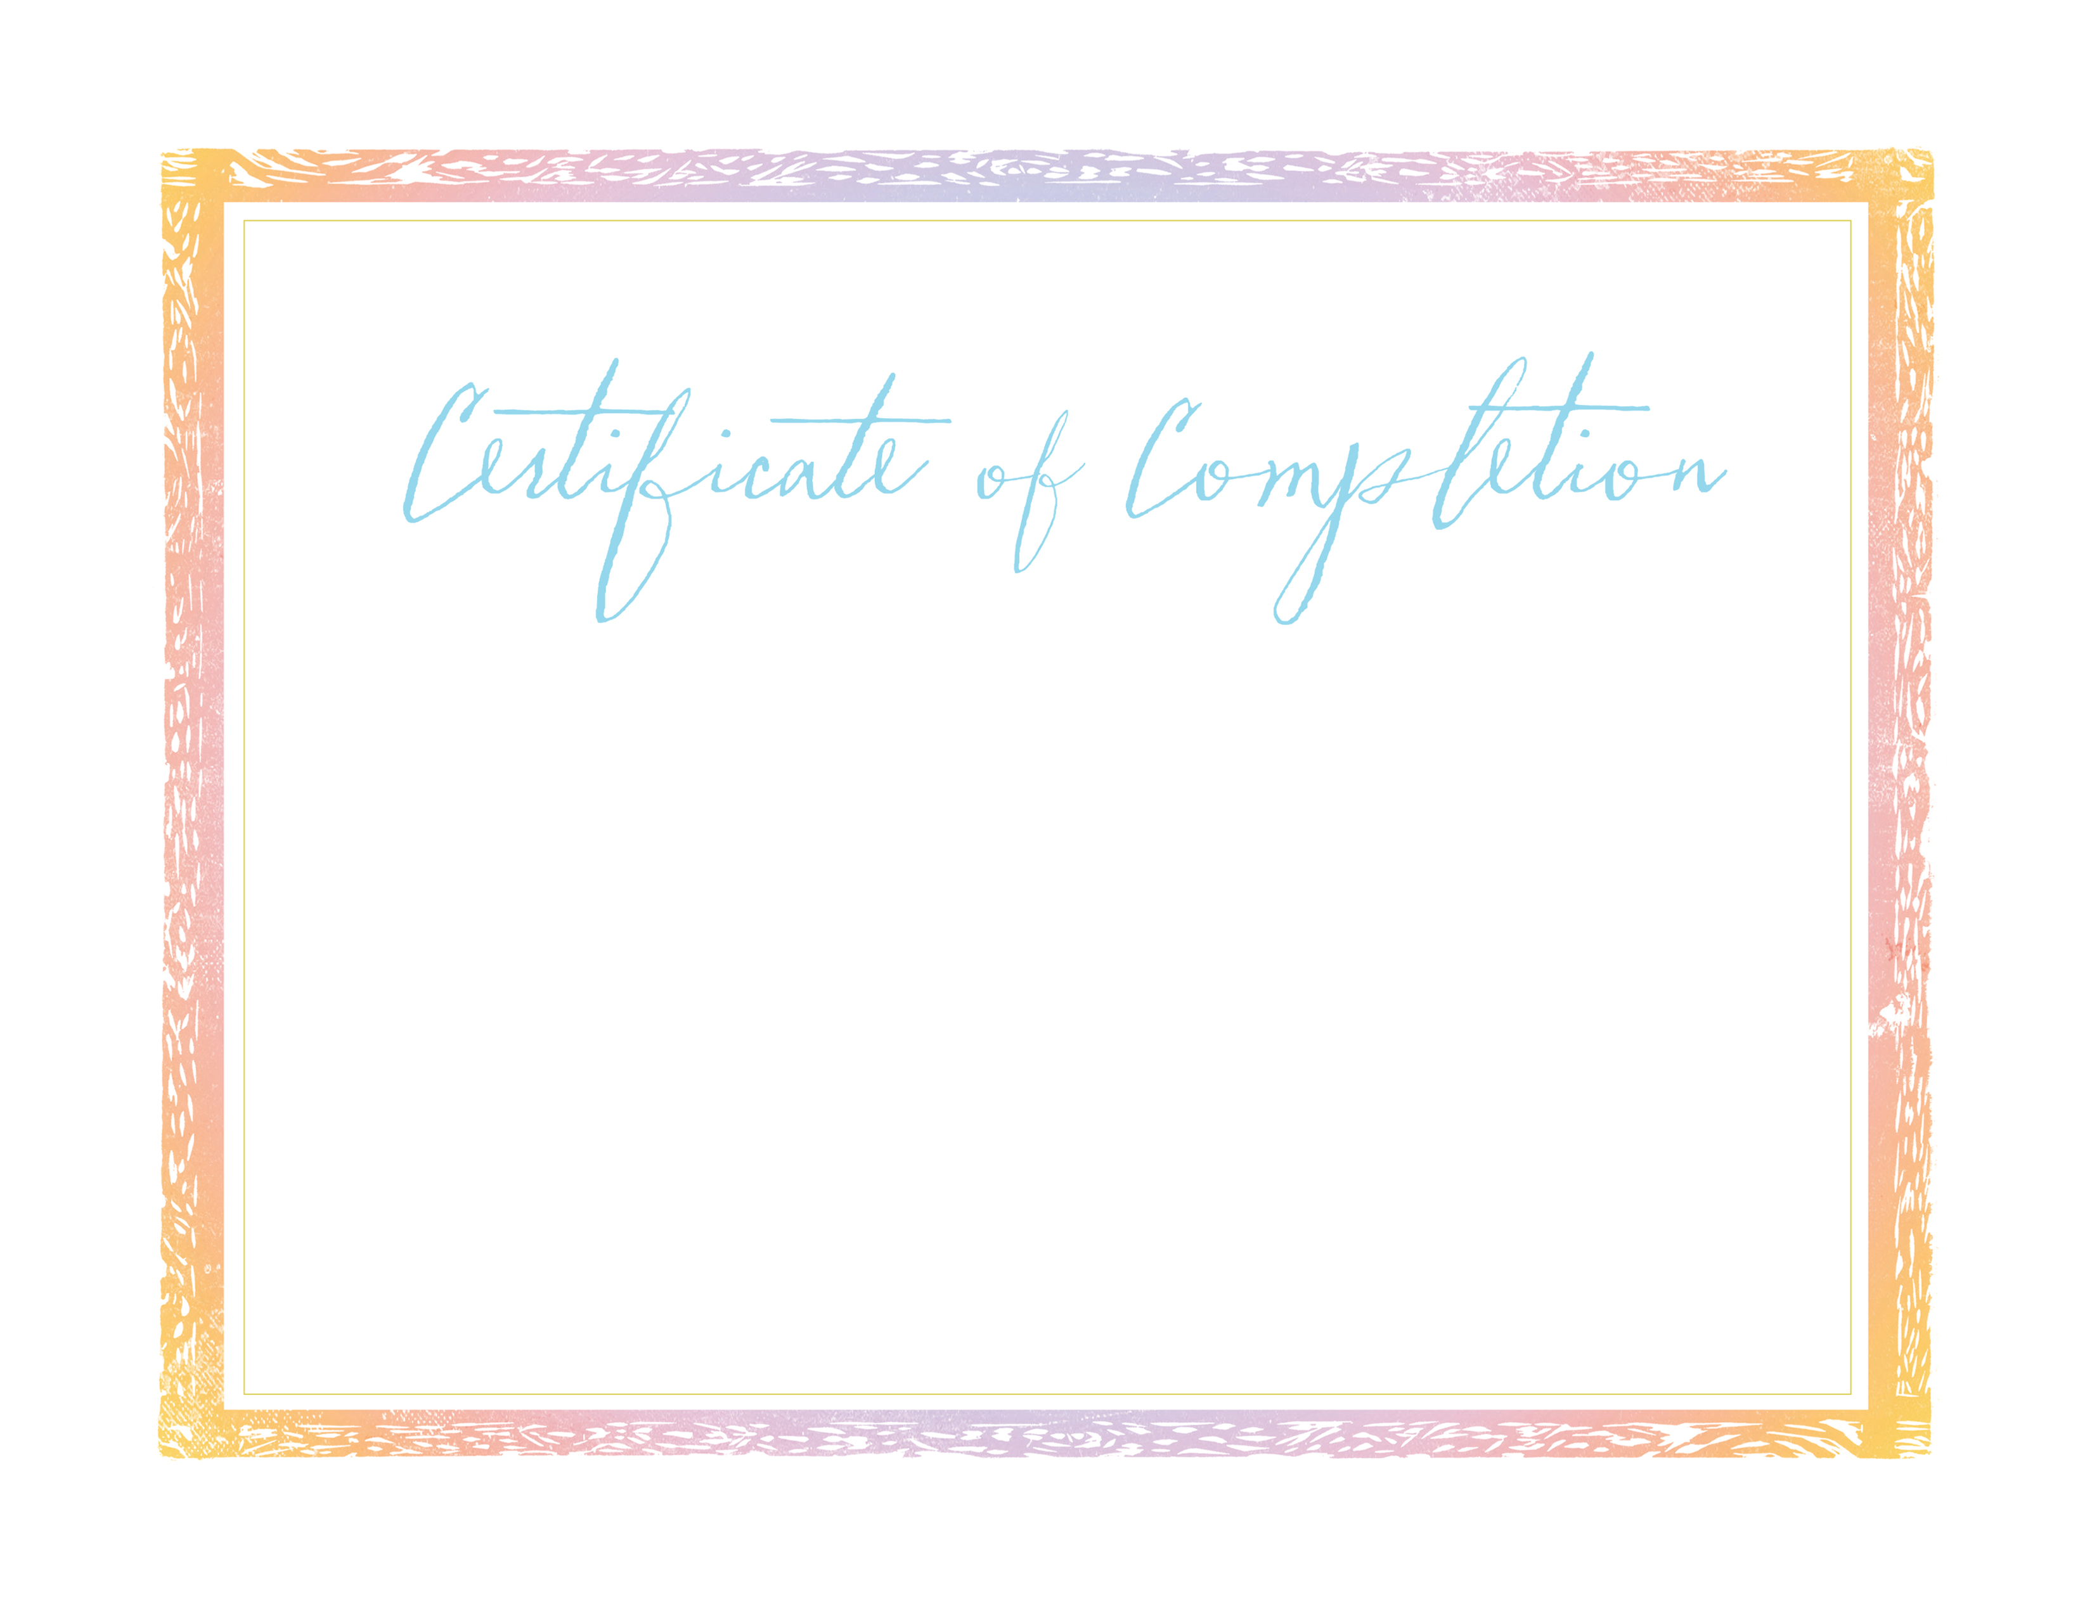

AWARDED TO

Type Name Here

in honor of her bible study completion and pledge memorization

at [Prison Name, City, State]

[Month, date, year]

Key verse

For this child I prayed, and the LORD has granted me my petition that I made to Him.  
Therefore, I have lent him to the LORD. As long as he lives, he is lent to the LORD (1 Samuel 1:27-28).

Pledge

As a Hannah’s Gift mom, I acknowledge that my children are a gift from God.  
I take hold of the call and responsibility as a mother and I seek God’s guidance on how to   
best parent my child. I am growing into a wise and strong woman of faith and my greatest desire   
is to leave behind a spiritual legacy carried on by my children to their children.  
May my family prove to be a tower of strength built on the firm foundation I am laying in the power of Christ.

______________________________________________________________________________________________

mentor signature date

Lifeline Global Ministries®

HANNAH’S GIFT™